Thank you for participating in Baylor University's Management Information Systems Career Night on Monday, February 26, 2024, in Foster 250 at 6 p.m. We are anticipating 200 Management Information Systems Majors will attend.

Location
Hankamer School of Business, Paul L Foster Campus for Business and Innovation
1621 S. 3rd St, Waco, TX 76706
Conference Center, Foster 250

Parking
Parking should be available in the Speight Parking Garage after 5:00 p.m.
1521 S. 4th St, Waco, TX 76706
The parking garage is on 4th St between Speight Ave and Bagby Ave.
Other Park: East Campus Parking Garage, Russell Gym Parking lot

Suggested Resources
Bring someone knowledgeable about careers in information systems and technology to speak on the panel.
Bring 2 people to interact with our students, maybe a new hire and a recruiter

Companies Attending
Capco, Cognizant, KPMG, and Walmart

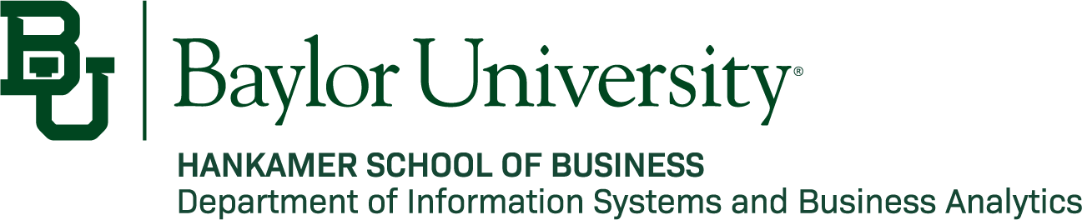
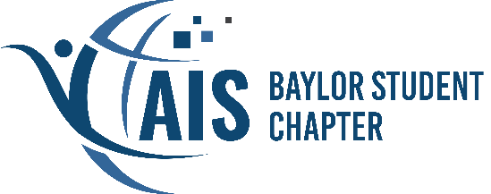

Schedule

SCHEDULE

TIME | ACTIVITY
5:20 | Park on campus, arrive at the Hankamer School of Business  We have designated an AIS officer to help your team get situated upon arrival  Relax in Foster 250 before the event
6:00 | Dinner: Move through buffet lines and talk with attendees  Company representatives should go through the buffet lines first and sit 1 representative/table so you can meet students.
6:30 | Introduction  Overview of the Night  About the Baylor Chapter of the Association for Information Systems (BAIS)  About your degree in Management Information Systems
6:40 | Panel
7:40 | Conclude and Transition to Networking
8: 15 | Wrap-Up
Preparation

The purpose of this Panel is to help students majoring in Management Information Systems and Business Analytics to start their career. Each panelist will answer questions from the BAIS officers running the Panel and the students attending. An ideal panelist is a hiring manager.

Panel Questions
- Please introduce yourself
- What is something you have been doing recently to recharge after a long week at work – hobby, show, book?
- Can you highlight some of the different opportunities in your company for IS professionals? What does the day-to-day look like in an entry-level role?
- Where do you see the future of IS heading and how do you think students can best prepare for it in their educational years?
- We’ve read that AI will replace 15% of the workforce this year. What IS related jobs will not get replaced by AI?
- How is your company currently leveraging AI in its operations or projects? What roles do you foresee AI playing in your industry over the next 5-10 years?
- How do you stay updated on the latest developments and trends in the Information Systems field, and do you have any recommendations for students to do the same?
- What skill set do students need to be successful in the IS field, either hard skills or soft skills?

Company Specific Questions:

Capco: Tyler Anderson
- In leveraging multi-platform development/technologies, Microsoft Suite, Computer-Aided Design (CAD), Reporting, and SCADA, how do these skills specifically contribute to your success in Information Systems consulting, and which skill has been the most valuable for your career?
- How has the variety of your education – computer info systems, engineering, and German – influenced your consulting approach within the IS industry?

Cognizant: Sampson Tsoi
- How did your time at Baylor contribute to your career, specifically in the IS industry?
- Can you elaborate on your experience with digital transformation?
- In your experience within the healthcare sector, could you provide specific instances where information systems have had a positive impact on the industry?

KPMG: Marcus Murph
- You have been with KPMG since 2004 – what have been the benefits of staying with the same company for so long, and what kept you there?
- Can you talk about your experience being a partner at a big four firm as a Christ follower?

Walmart, Derek Brooks
- Can you talk about your experience as a young professional switching between incredible companies every year or so? How has this diversity benefited you?
- Can you speak on your experience with the intersection of HR and information systems? Specifically, how does Walmart leverage information systems to streamline recruitment processes?

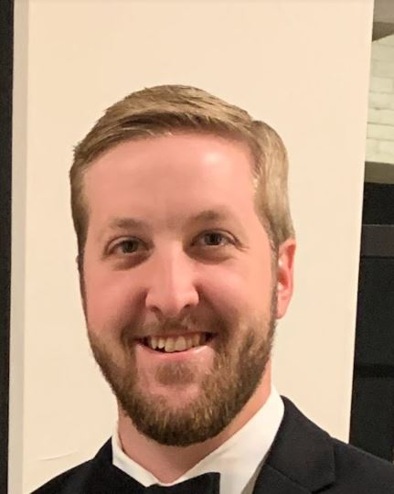
Tyler Anderson
Tyler Anderson, Panelist
Senior Consultant at Capco
https://www.linkedin.com/in/tyler-anderson-41b2746a/

Joshua Eapen
Associate Consultant
https://www.linkedin.com/in/joshua-eapen/

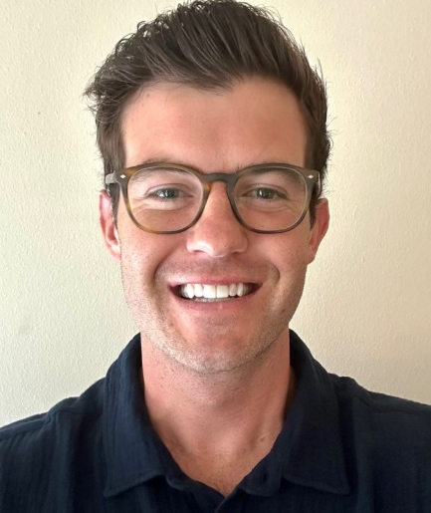

Derek Brooks
Senior Manager, HR - Corporate Finance and Strategy
https://www.linkedin.com/in/derekjames84/

Sampson Tsoi
Senior Director
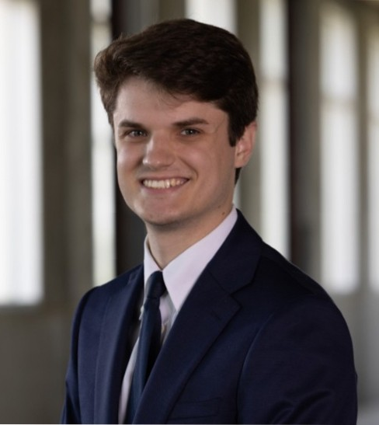
https://www.linkedin.com/in/sampson-tsoi-8b92781/

Peter Johnson
Business Analyst
https://www.linkedin.com/in/peter-e-johnson/

Neeha Kilari
Campus Recruiter https://www.linkedin.com/in/neeha-kilari-03 13snk

Lisa Marie Resendez
Campus Recruiter
https://ww w.linkedin.com/in/lisamarieresendez/

Marcus Murph
Partner, Technology Advisory Practice Leader https://www.linkedin.com/in/marcus-murph-2593 a/

Dorie Stewart
Senior Associate Talent Acquisition https://www.linkedin.com/in/dorie-stewart-225109114/

Katherine Ricci
Technology Assurance Senior Associate
https://www .linkedin.com/in/katherine-ricci/

Tyler Anderson

Role
Senior Consultant at Capco
Connect
https://www.linkedin.com/in/tyler-anderson-41b2746a/
Background
Experienced Senior Consultant with extensive experience and focus around Program management and creation, mobile enablement for large and small scale organizations.
• Strong background in electric and public utility, electrical transmission and distribution, natural gas transmission and distribution, design and control systems technology and architecture.
• Program and project management experience for work and asset management in the field. Leading integrations with design, maintenance, and restoration systems to enable field personnel to digitize and improve efficiencies.
• Leader in mobility strategic planning, road mapping, and scalability planning for continued growth.
• Worked with field personnel, directors, and technology leaders to define, plan, and implement strategic transformation initiatives to improve engagement and throughput.
• Maintained and managed growth of mobile program from six to eight-month efforts into multi-million dollar field app portfolio (22+ mobile applications).
• Experienced in solutioning multi system integration and troubleshooting complex problems.
Tyler is skilled in mobile program creation and maturity, project management, program management, Multi-platform development/technologies, Microsoft Suite, Computer-Aided Design (CAD), Reporting, and SCADA. He has considerable experience in the energy industry. Tyler is a strong consulting professional with a Bachelor’s Degree focused in Computer Information Systems with minors in Engineering and German from Baylor University.

Derek Brooks

Role
Senior Manager, HR - Corporate Finance and Strategy
Connect
https://www.linkedin.com/in/derekjames84/ Background
Derek's professional journey is marked by a rich background of experience and an unyielding commitment to innovation and strategic growth. A Baylor University alumnus, he embarked on his career in 2013, honing his expertise in strategy and continuous improvement as a consultant for industry giants like Allstate and Liberty Mutual. His prowess in driving innovation flourished through his consultancy tenure until 2019.
Seeking to broaden his horizons, Derek transitioned into a pivotal role in strategic communications and change management, focusing on mergers and acquisitions at Gallagher in 2019. This role was a cornerstone in his career, setting the stage for his return to the tech realm in 2020 as a Program Manager at Dropbox, where he spearheaded workforce planning initiatives.
Derek's multifaceted background paved the way for his notable tenure at Amazon, where he initially embraced the role of Senior HR Business Partner for Amazon Music's Product and Tech divisions. His impact in this position was profound, leading to his current role as the Senior HR Manager in Corporate Finance, Strategy and Innovation, and Tech.
In his current capacity, Derek leverages his vast experience across various corporations and roles to excel and drive meaningful change. His unique blend of skills, coupled with a reflective approach to the integration of people and technology, has been instrumental in his success. His hands-on experience not only enhances his effectiveness in his present role but also positions him as a visionary leader poised for continued success in future endeavors.

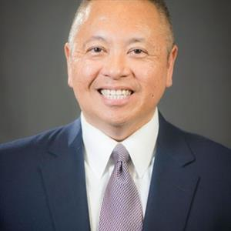

Role
Executive Director at Cognizant
Connect
https://www.linkedin.com/in/sampson-tsoi-8b92781/ Background
I am a consultant and consulting leader with extensive experience in Change Adoption, Workforce Transformation, Organization Change Management (supporting large scale change esp. Technology Driven Change, technology implementations) and Digital Transformation.

I have over two decades of professional consulting experience helping clients to prepare, transition and arrive at their desired state of business transformation.

My other skills include Continuous Improvement (Process Improvement), Training and Development, Organization Design, Benefits Realization and business development.

I have experience in the Life Sciences (Pharmaceutical, Medical Devices), Healthcare, Retail, Consumer Products and Travel and Transportation industries.
.

Marcus Murph

Role
Partner, Technology Advisory Practice Leader Connect
https://www.linkedin.com/in/marcus-murph-2593a/ Background
Marcus has over 20 years of experience helping Fortune 100 organizations leverage technology to drive enterprise transformation. He has direct hands-on experience helping clients define, analyze and solve critical business problems to drive operational improvement, cost efficiency and enable quantifiable results. Navigating the world of disruptive technology is complex. The number of technology providers in the marketplace and the number of technology buyers within your organization grows every single day. He helps clients understand the ever-increasing complexity of the technology landscape and determine how they can exploit technology to both grow the top line and optimize the bottom line. He can help bridge the gap between traditional technology centric organizations like IT and the broader back and front office organizations to drive unified outcomes across the enterprise. The answer is rarely about implementing a specific tool. Whatever the context, digital, cloud, intelligent automation, data & analytics, etc., he can help organizations cut through the hype, and define a realistic strategy that is appropriate to your business.

